## **TEI Website Requirements**

(Last Updated 1/31/18)

## 1 Site Configuration

* Custom branding with TEI’s logo, branding, colors, and domain mapping
* Blog/news feed capability
* Site structure based on TEI requirements
* Mobile/tablet-compatible, responsive site design
* Flexible site functionality configured based on TEI needs
* User registration and authentication through OMB MAX. The system shall have multifactor authentication. (See 5. Access to System)

## 2 Learning Program Management

The main purpose of the system is to allow for easy registration to learning sessions by participants and management of those sessions by administrators.

### 2.1 Learning Program (Session) Management for Administrators

* Ability to register, cancel or input attendance, late cancellation, or absences—and be able to search against those actions for various timeframes.
* Ability to limit the number of users who can register for each course, with a wait list started when a course reaches capacity
* Ability to manage waitlist, i.e. receive a message when someone cancels and there is a waitlist so they can choose to move someone into the space (or not).
* Ability to have deadlines that close off registration.
* Ability to identify completed courses for certificates and/or online badges so a message can be sent for participant to complete the application.
* Ability to input and search by vendor/speaker (fields should include name, background, cost, contact information)
* Ability to add comments to be seen only by administrators for any session.
* Easy, intuitive way to input sessions and organize for display.
* Ability to upload or update more than one program at a time preferred.
* **ASSUMPTION:** TEI will not track out-of-platform learning experiences.

### 2.2 Learning Management for Participants

* Ability to Search by theme/topic
* Ability to register for available classes or become waitlisted for full classes
* Ability to select in-person or online attendance during registration
* Ability to cancel registration
* Ability to get a full screen of all the available courses and register at once for all (place check mark by all want and hit submit just one time) versus now having to do one at a time.
* **Future:** Hosting of online learning content in multiple formats (video, interactive, PDF, audio, etc.)

## 3. Messaging

Ability to send automated messages to TEI administrators, and manual messages to clients and coaches with new course announcements, reminders and other information. The automated Calendar Invites and reminders need to have adjustable frequency and messaging. Messaging should *appear* to come from appropriate TEI mailbox (i.e. LEAD or coaching-services).

### 3.1 Automated Messaging

* User registers or withdraws
* Notification of registration status (registered vs waitlisted)
* Assignment / match made: notification sent to Coach and Client
* Assignment complete: notification sent to client once Coach marks complete
* ASSUMPTION: Administrators will not receive a notification if a user receives an error for the wrong (too low) GS level.

### 32 Communications--Messaging

* **New Course Availability** via SMS or email
* **Reminders**: Pre-course reminders to course participants via SMS or email
* **Certificates of Completion**: Users can download and/or email certificates through the platform. Admins must create and upload certificate imagery into the platform.

## 4 Reporting

### 4.1 General Dashboard

TEI's administrators can access data on their specific users' engagement with TEI's programs on the site. (Tracked history of searched courses with trends over time available by request.)

The dashboard will provide a snapshot of data that TEI administrators can drill down into on a partner basis.

On the General Dashboard, Administrators will be able to download CSV-formatted cumulative activity reports for:

* User profile information to include fields for: Last name/ first name/ email address/ Agency / Department / Grade (GS-level)
* All program/course activity – (start/end date, program name, delivery method)
* Ability to capture program participation (attended/cancelled/no show)
* All coaching open and closed assignments, reported coach hours and available coaches.

This will enable TEI staff to sort this data by various (any) fields as needed.

#### 4.1.1 Access

TEI Administrators will have access. Participants who are not TEI Administrators should not be able to view this dashboard.

#### 4.1.2 User interaction and Design

See “General Report.png”

### 4.2 Partner Dashboard

TEI Administrators and Partner Agency Administrators can access detailed data on their partner’s users’ engagement with TEI's programs.

TEI Administrators will be able to view detailed data for each Partner organization showing an aggregated summary of activity, along with a list of specific users from each partner based on reports provided by TEI.

Partner Agency Administrators will be able to view only the aggregated summary of activity. They will not be able to view the list of specific users from their organization. This access can be added upon request from TEI. There will be 3 customizable fields for later use.

#### 4.2.1 Access

TEI Administrators will be able to view detailed reports for each Partner organization showing an aggregated summary of activity, along with a list of specific users from each partner.

Partner Agency Administrators will be able to view only the aggregated summary of activity. They will not be able to view the list of specific users from their organization. This access can be added upon request from TEI.

#### 4.2.2 User Interaction and Design

See “Overview (Program Admin View - No Tabs).png”; “All Users.png”; “Coaches.png”; and “Clients.png”

### 4.3 User Dashboard

TEI Administrators can go to access data on their users' engagement with TEI's programs.

#### 4.3.1 Access

TEI Administrators will have access. Participants who are not TEI Administrators should not be able to view this dashboard.

#### 4.3.2 User Interaction and Design

See “Overview.png” and “Coaching Details.png”

### 4.4 Course Dashboard

TEI Administrators can go to access data on their users' course enrollment, capacity and attendance with TEI's programs through the platform.

#### 4.4.1 Access

TEI Administrators will have access. Participants who are not TEI Administrators should not be able to view this dashboard.

#### 4.3.2 User Interaction and Design

To be provided.

## 5 Access to System

* Users will register and authenticate using OMB Max
* TEI will have the ability to register ad hoc users—if an ad hoc user register for the first time through OMB Max, the ad hoc file should be joined to the new profile.
* The system shall have multifactor authentication.

### 5.1 Eligible Users

**Whitelist of Eligible OMB MAX Group(s)**

1. **TEI ACTION**: TEI staff add users to the TEI group in OMB MAX based on the lists they receive from their partners.
2. **USER PROFILE:** All users must complete to participate in the TEI portal. When a user attempts to log into TEI Connect the first time, the system checks to see if that individual is a member of the TEI group on OMB MAX.
   * If the user is a member of the TEI group, they are allowed to log in.
   * Upon their first log in, they must complete the user profile items not pulled from OMB Max to include:
     + Client’s name Last name/ First name (OMB MAX)
     + Agency (OMB MAX)
     + Subagency (OMB MAX)
     + Unit (dropdown)
     + Phone (OMB MAX)
     + Mobile Phone (phone number field, XXX-XXX-XXXX)
     + Email (OMB MAX)
     + LMS User ID (from their agency for downloads)
     + GS grade level (dropdown)
       1. GS14 or equivalent
       2. GS15 or equivalent
       3. SES or equivalent
   * If the user is not a member of the TEI group, they are shown an error message and prevented from accessing TEI Connect.
3. **CONSIDERATIONS:**This a slightly more manual option compared to the others, since it requires TEI staff to upload user lists to OMB MAX and make sure those lists are accurate. However, it does provide flexibility, since access is managed by TEI staff directly, and the registration filter on TEI Connect is greatly simplified.

## 6 Media

**Accepted document formats:**co, jpg, jpeg, png, gif, mov, avi, mpg, 3gp, 3g2, midi, mid, pdf, doc, ppt, odt, pptx, docx, pps, ppsx, xls, xlsx, key, mp3, ogg, wma, m4a, wav, mp4, m4v, webm, ogv, wmv, flv, zip

### 6.1 Additional Media Information

* Ability to playback videos of taped sessions
* Ability to discussion boards
  + General for all
  + Specific to programs/cohorts
* Practice environments for learning (i.e. ability to record participant input)
* Ability to post leader boards by instructors
* Ability to host chats
* Ability to provide social media (hosting and management abilities)

## 7 Permissible Content Types

## Configure Salesforce to manage and report on TEI training content

## 8 Coach Profiles

All users must complete to participate in the TEI portal the coaches have additional fields.

### 8.1 Form Fields (Purple items should be from user profile)

* Name (OMB MAX)
* Agency (OMB MAX)
* Subagency (OMB MAX)
* Phone (OMB MAX)
* Email (OMB MAX)
* GS grade level (dropdown)
  + GS14 or equivalent
  + GS15 or equivalent
  + SES or equivalent
* Available to Coach (dropdown)
  + Yes
  + No
* Coaching Status (dropdown)
  + Training
  + Completed Training
  + Certified
  + *If certified, dropdown:*
    - ACC
    - MCC
    - PCC
* Conflict of Interests (text field)
* Coaching Style (text field)
  + Hint text: Share a description of your coach approach and style. You may want to include instruments you use frequently. Also, please insert a picture here.
* Career Highlights (text field)
  + Hint text: Provide a brief description of your career in paragraph or bullet form. Be sure to include where you have worked and major accomplishments.
* Functional Experience (text field)
  + Hint text: Using bullets, provide functional areas you have worked in
* Educational Background (text field)
  + Hint text: Using bullets, list education
* Other Notable Information (text field)
  + Hint text: Please provide any other information you would like to share! This can be personal or professional—you choose.
* Image (PNG or JPG upload; optional)

### 8.2 Additional data that will appear on coaching profile, populated by the portal

Past and current assigned client(s)

### 8.3 Dependencies

OMB MAX configuration

## 9 Client Coaching Applications

All client users will be required to fill out to participate in the TEI portal.

### 9.1 Form Fields (Purple items should be from user profile)

* Client’s name (OMB MAX)
* Agency (OMB MAX)
* Subagency (OMB MAX)
* Unit (dropdown)
* Phone (OMB MAX)
* Mobile Phone (phone number field, XXX-XXX-XXXX)
* Email (OMB MAX)
* GS grade level (dropdown)
  + GS14 or equivalent
  + GS15 or equivalent
  + SES or equivalent
* Preferred Time of Day (mark all that apply)
  + Morning (checkbox)
  + Midday (checkbox)
  + Afternoon (checkbox)
    - Time zone (dropdown)
* 1-2 Paragraph Bio (text field)
* Description of two goals or outcomes you would like to achieve through the TEI Coaching process. (text field)
* Additional information that might be helpful in assigning a coach for you. (text field)

### 9.2 Additional data that will appear on client profile, populated by the portal

* Indicate whether or not they are currently paired with a coach
* Current assigned coach

NOTE: Not available for public access

### 9. 3 Dependencies

OMB MAX configuration

## 10 Coach Matching

* Client Users will fill out a form to request coaching services
* Once submitted, an automatic email notification will go to designated TEI administrators
* TEI administrators can then review the submission and browse the list of coaches to determine the coaching assignment
* Matches must be approved by an administrator before they are processed
* Automatic emails will be sent to client and coach when they are matched

## 11 Future: Evaluations

* Ability to create custom evaluations for sessions and coaching with questions / fields as determined by TEI administrators
* Ability to customize email messaging for each evaluation managed
* Access to the evaluation data will need to be set at the user level, as some coaches will need administrative rights
* Ability to create evaluations at regular intervals before / after the course
* Ability to set durations for how long each assessment is open to participants
* Ability to create pre-course mini surveys and course pre-work (e.g. why did you decide to register?, why did you decide to cancel?, watch this video ahead of your course, etc.)

Appendix A: System PerformanceObjectives From PWS

|  |  |  |  |
| --- | --- | --- | --- |
| **Performance Objective** | **Standard** | **Performance Threshold** | **Method of Surveillance** |
| The contractor shall refine and tailor the Salesforce prototype, via configuration and/or minimal development (JavaScript, HTML, CSS, Apex, Lightning Components) into a fully functioning solution which meets TEI’s business needs. | Configure system database and functionality; development as needed to meet requirements | Final deliverable may not contain more than 5% of errors/issues with configured or developed features. | Validated through user acceptance testing and formal notification to COR. |
| The contractor shall integrate Salesforce with OMB MAX to facilitate a secure authentication process for TEI partners, customers, and staff. | System accessibility & security compliance | 100% completion within a mutually agreed upon timeframe | Validated through user acceptance testing and formal notification to COR. |
| The contractor shall develop and execute a deployment plan to replace the current WordPress solution with the finalized Salesforce solution. | Timeliness / Deliverables completed on time. | 100% completion within a mutually agreed upon timeframe. | Validated by TEI PM & COR. |
| The contractor shall participate in regular meetings and planning activities with the TEI Project Manager to ensure work is managed and completed in a timely manner. | Timeliness | 100% attendance and participation of meeting times, agendas and activities mutually agreed upon. | Review of weekly status updates and meeting minutes. |
| The contractor shall provide training and briefings to the TEI staff in preparation for operations and maintenance of the Salesforce solution. | Timeliness / Deliverables completed on time. | 100% completion of deliverables within a mutually agreed upon timeframe. | Validated by COR |
| The contractor shall provide support in the migration of web content from the current WordPress solution to Salesforce. | Maintain an electronic database. | No less than 70% of the web content shall be migrated by the contractor, 100% completion within a mutually agreed upon timeframe. | Review and compare content between sources. |

Appendix B: Former TEI Connect Screen Shots

**Visually friendly Homepage with a Featured section for advertising and a place to load the catalog.**

# Home Page:



# 

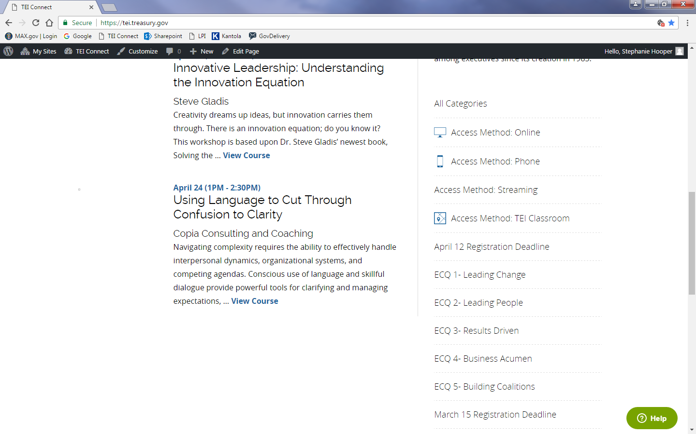

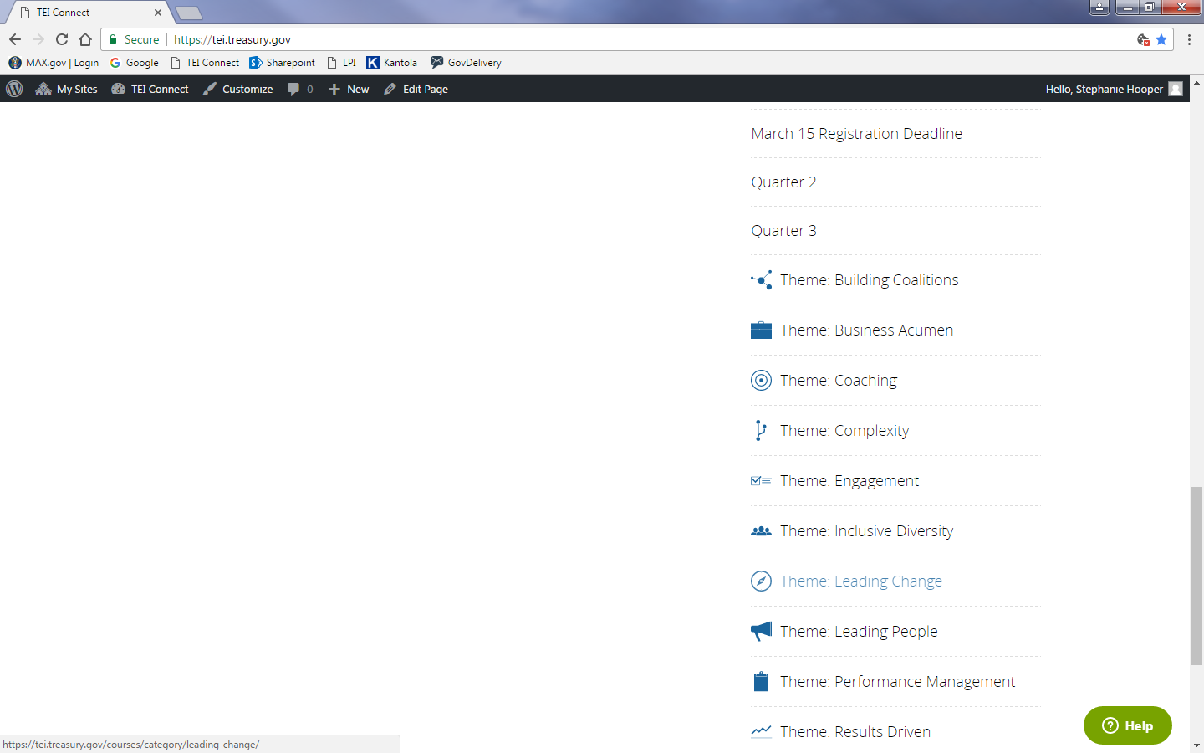

# TABS:

**The platform must each of the tabs and sub-tabs displayed in the screen shots below.**



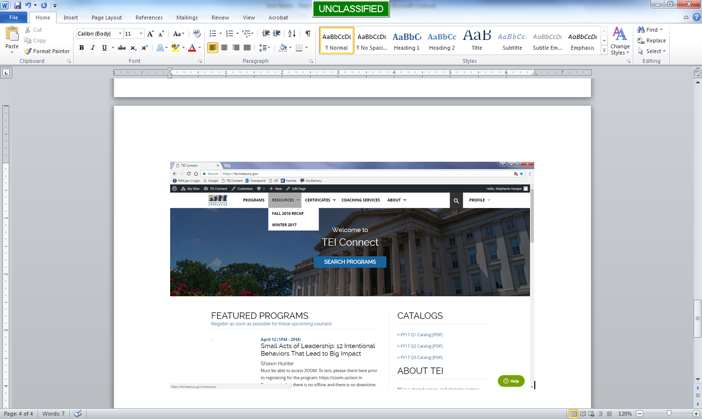  

# PROGRAM PAGE (Listing):

**The main information that should be listed in the title is:**

1. Title
2. Date
3. Time
4. Method of Delivery
5. Facilitator/Author
6. Registration Deadline

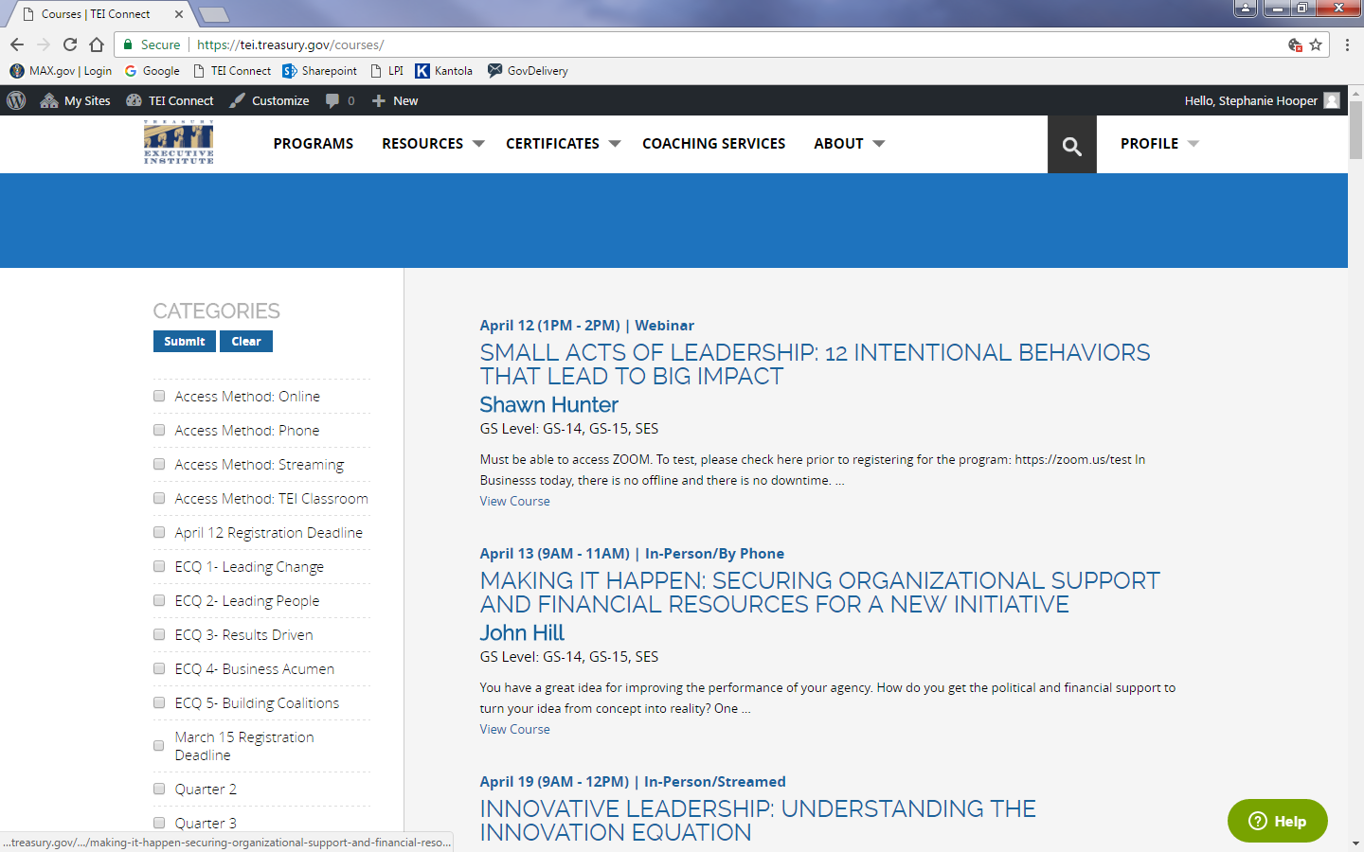

# Program Details Page:

**Course Detail Requirements**

Same information as above displayed again

Additional Sections:

1. Program Description box
2. Register or Un-enroll button
3. Name
4. Email
5. Attending In-Person or Phone/Stream



# Program Overview Page:

**Registration List details needed**

1. List of Registrants time stamped in chronological order
2. Registrant section broken up from Waitlist still in chronological order
3. With columns of:
   1. Name
   2. Email
   3. Partner
   4. Grade
   5. Timestamp
4. Ability to be downloaded in an Excel Workbook format

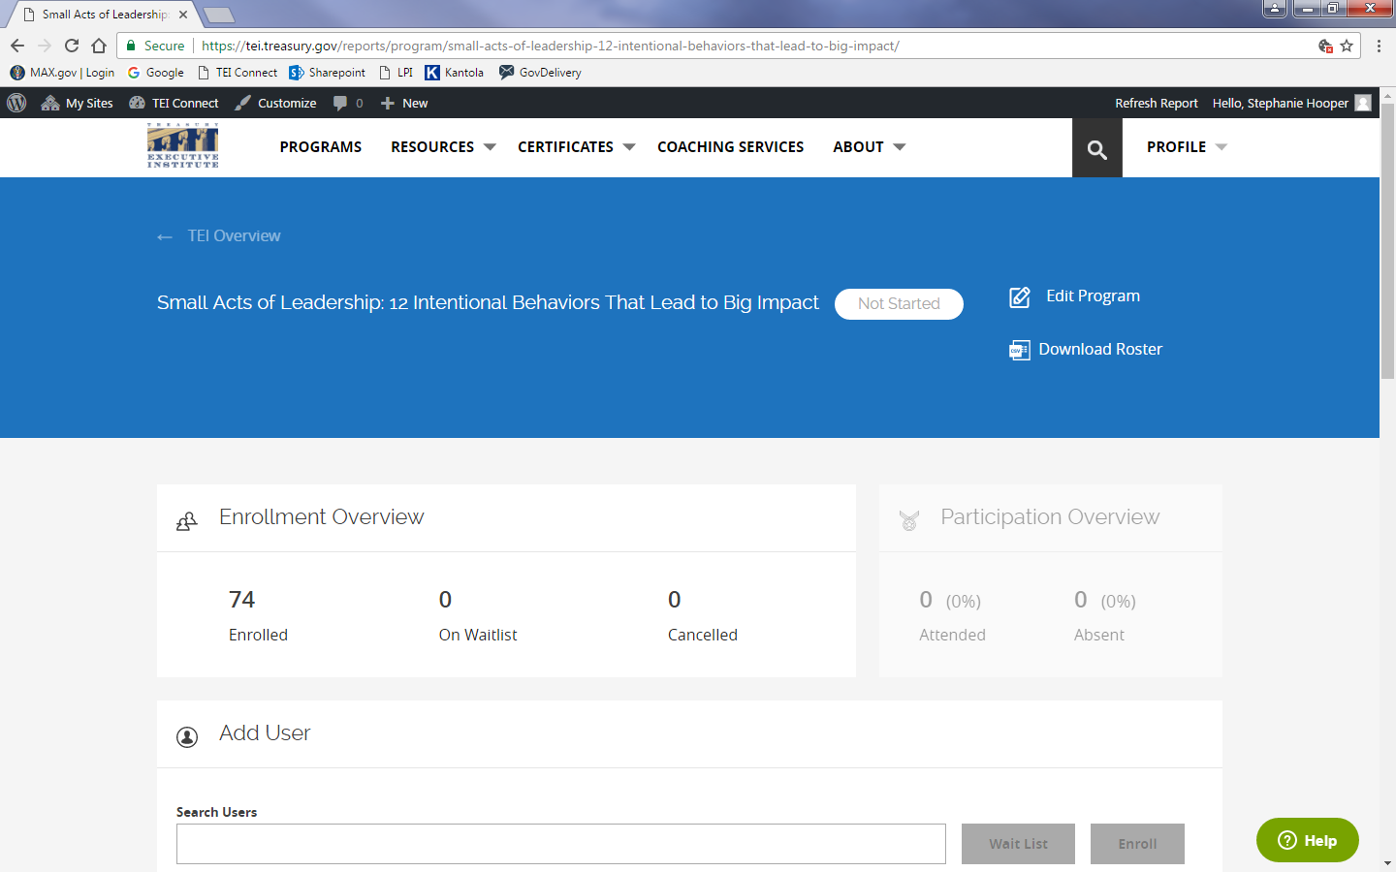 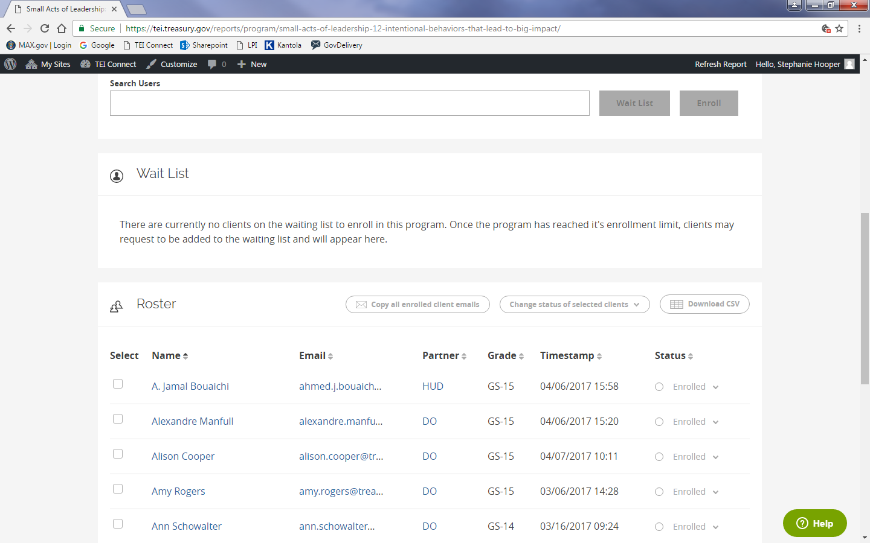

Administrator Pages

# DASHBOARD VIEW/PAGE:

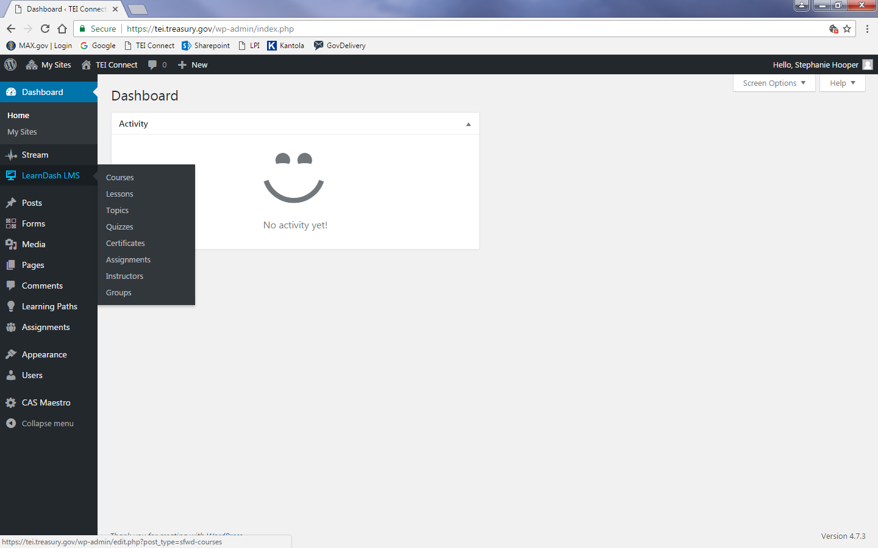

# User Search and Profile Pages:

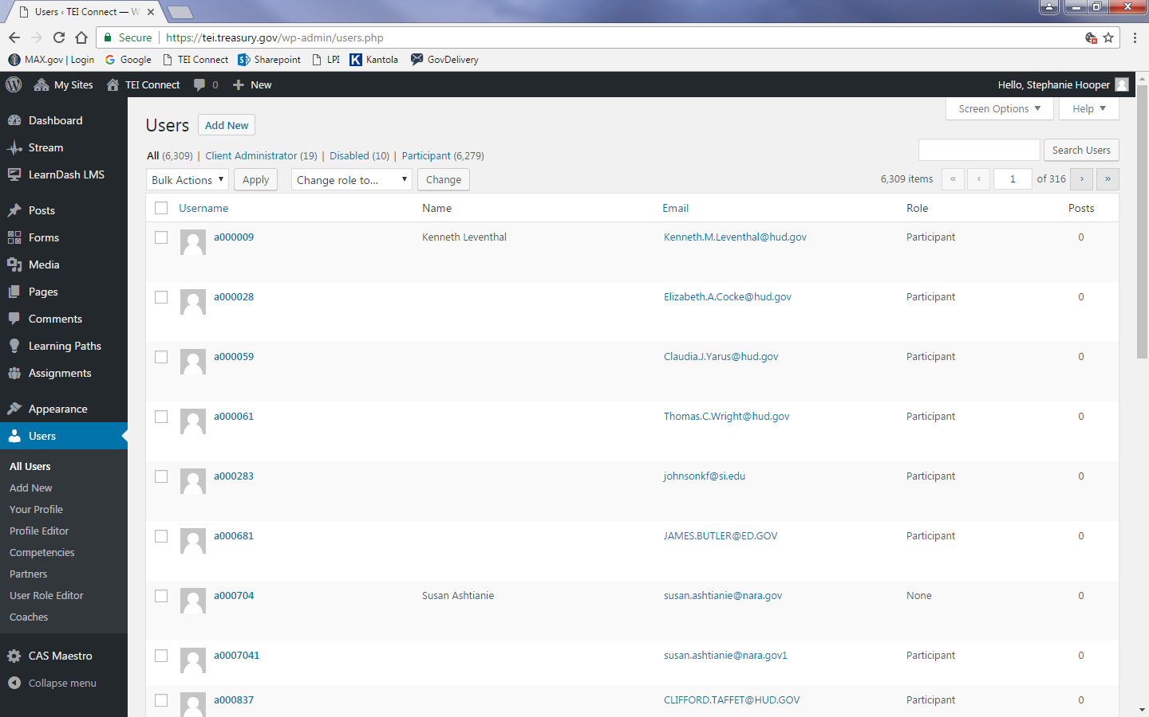

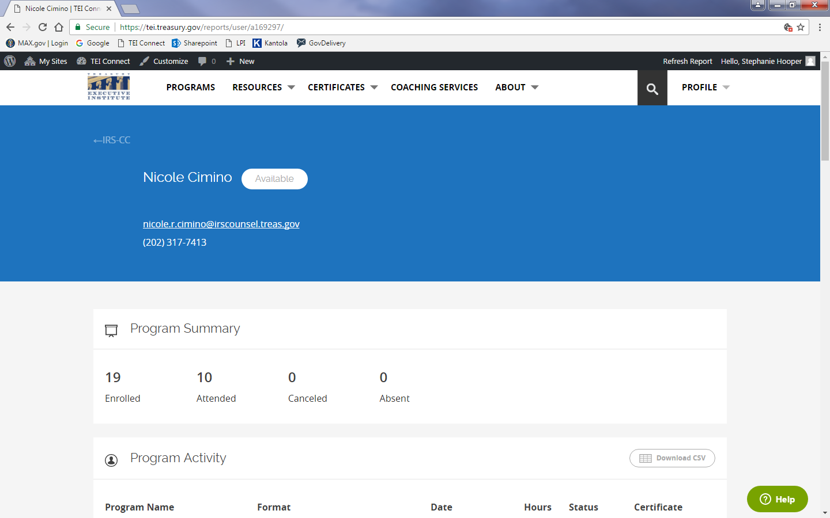 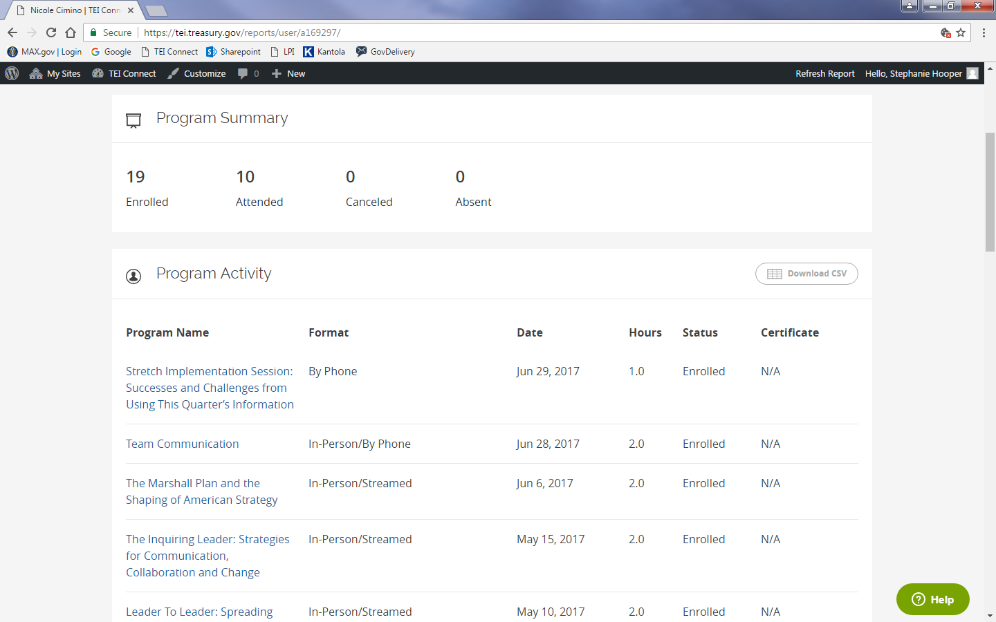 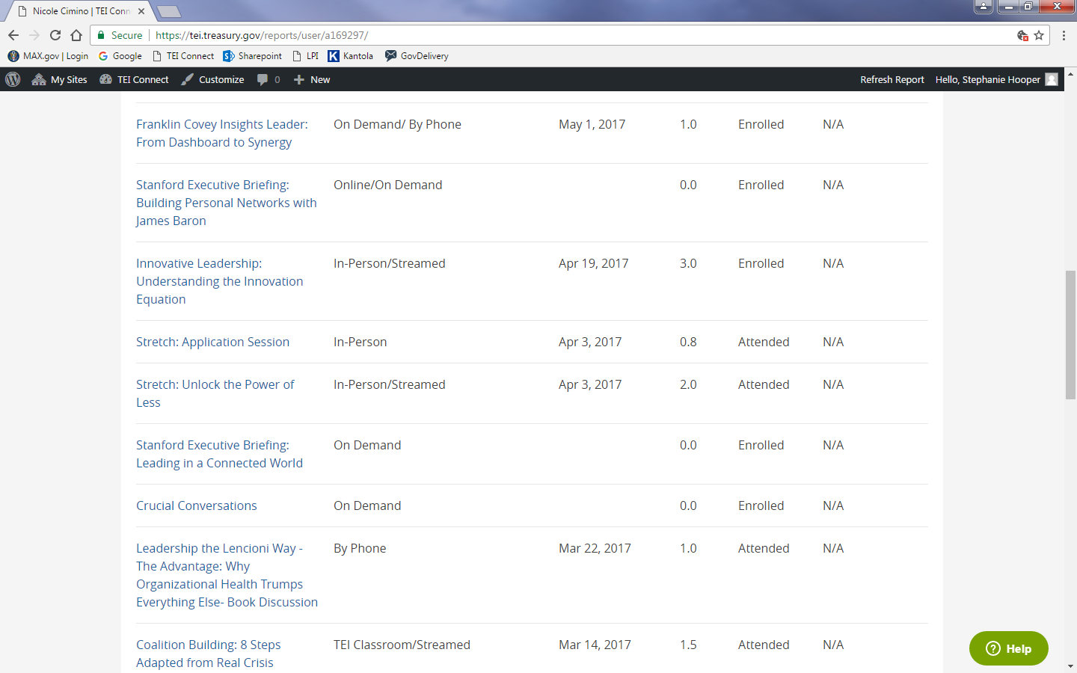

# Course Listing Page:

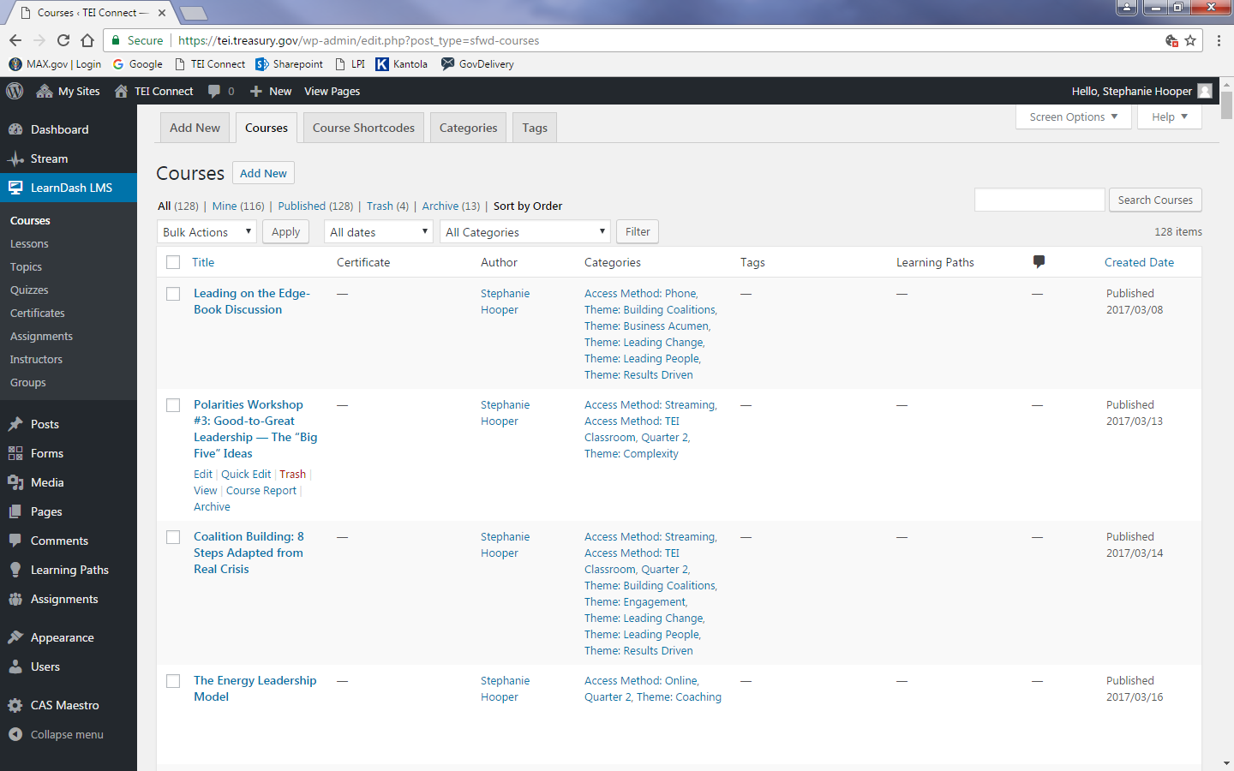

# EDIT COURSE PAGE:

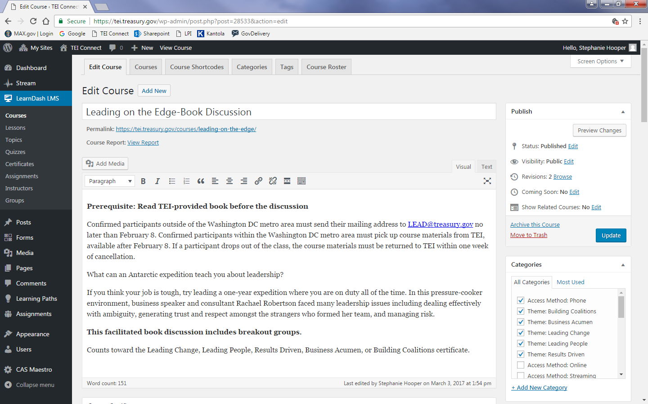

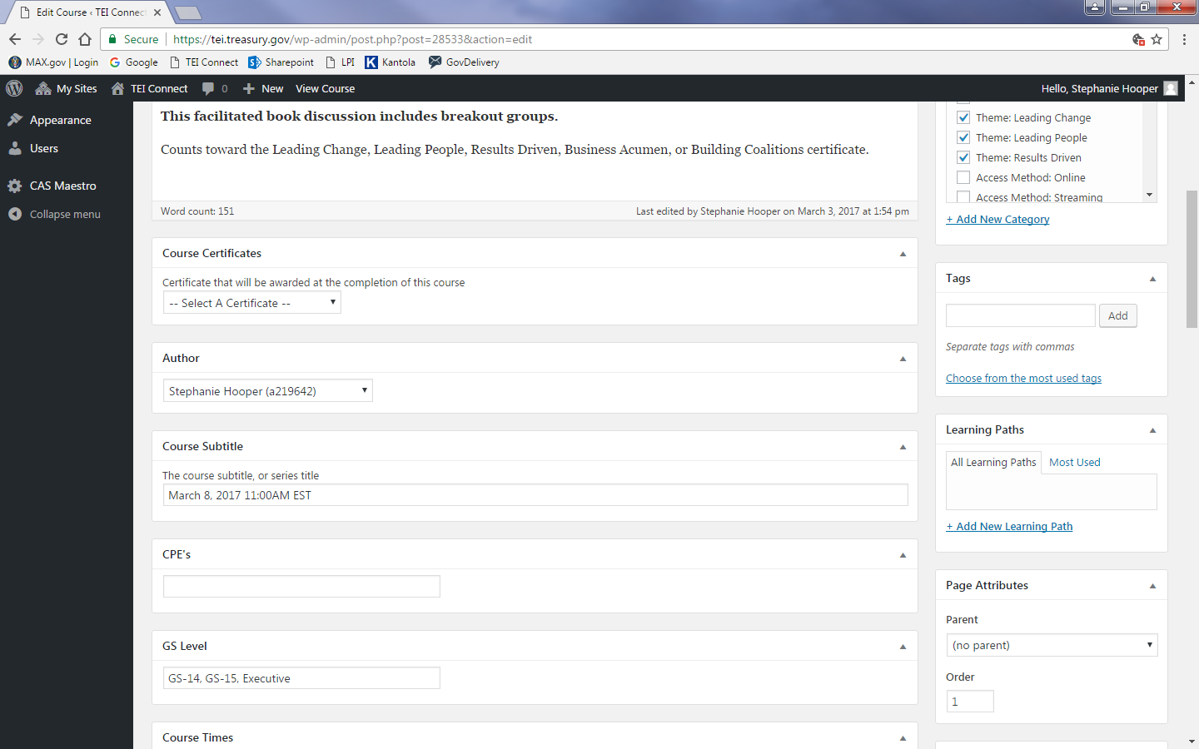

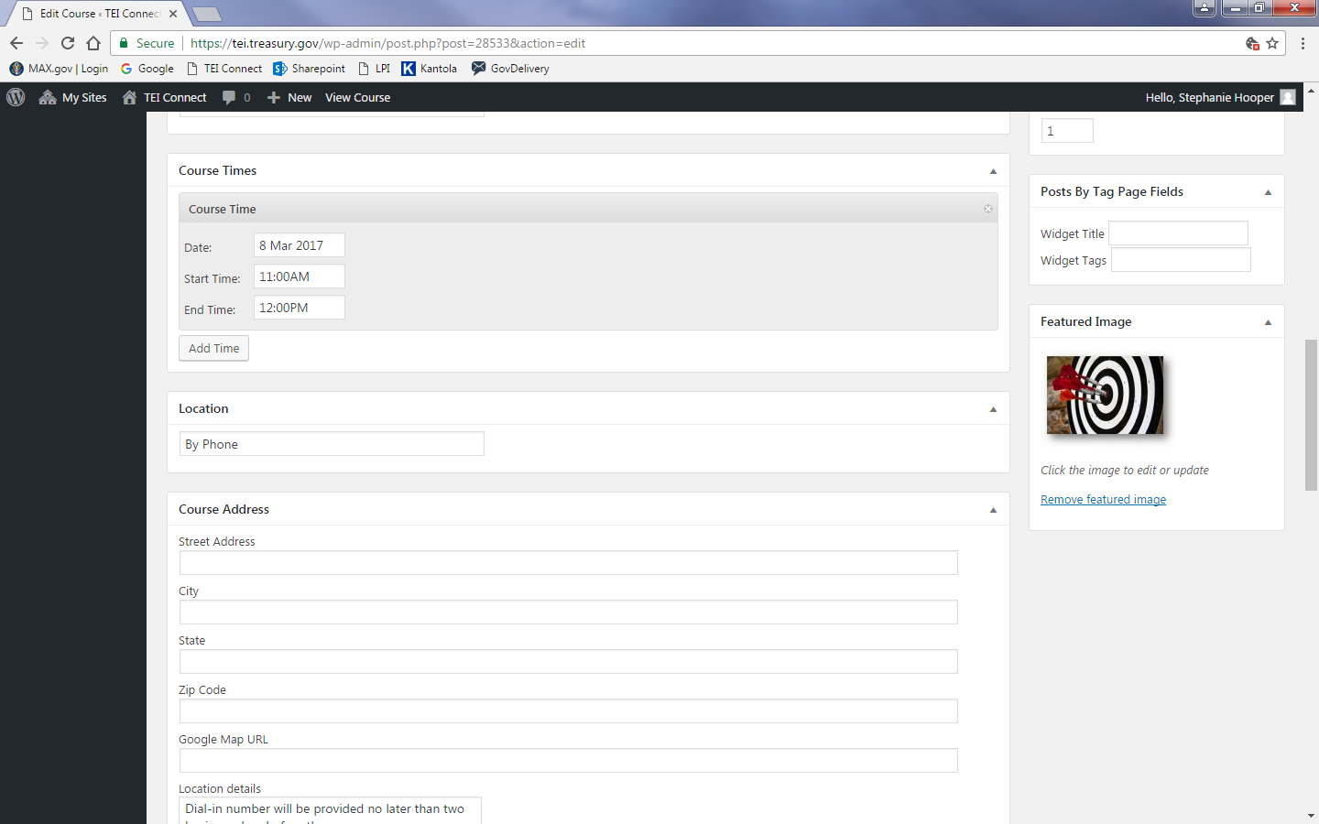 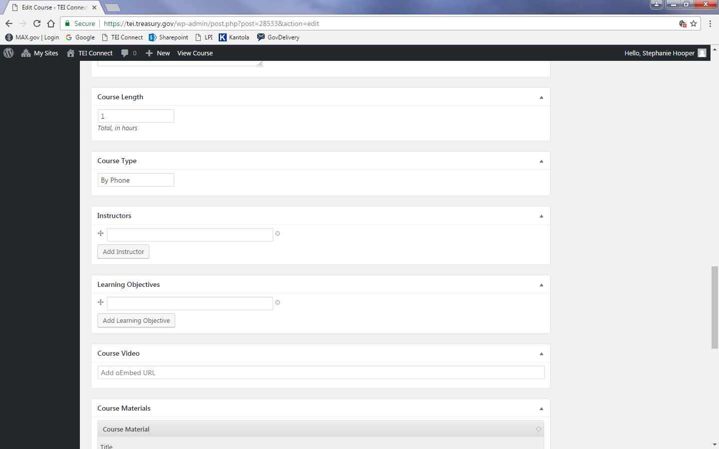 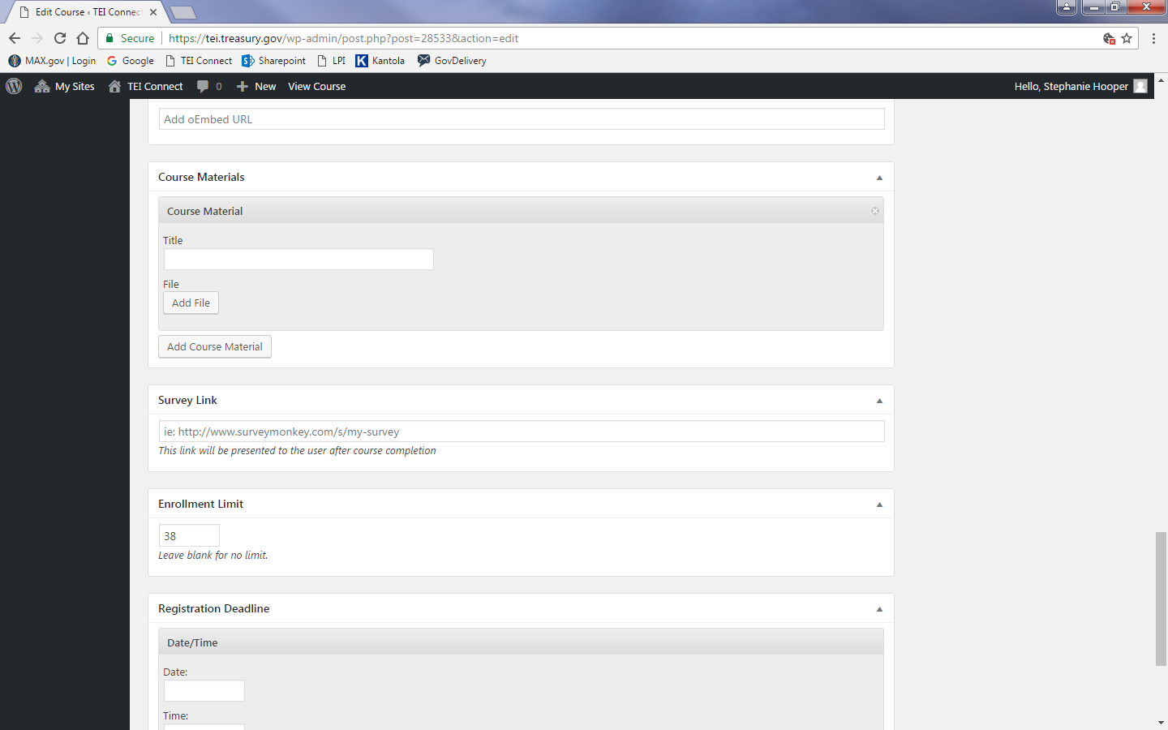 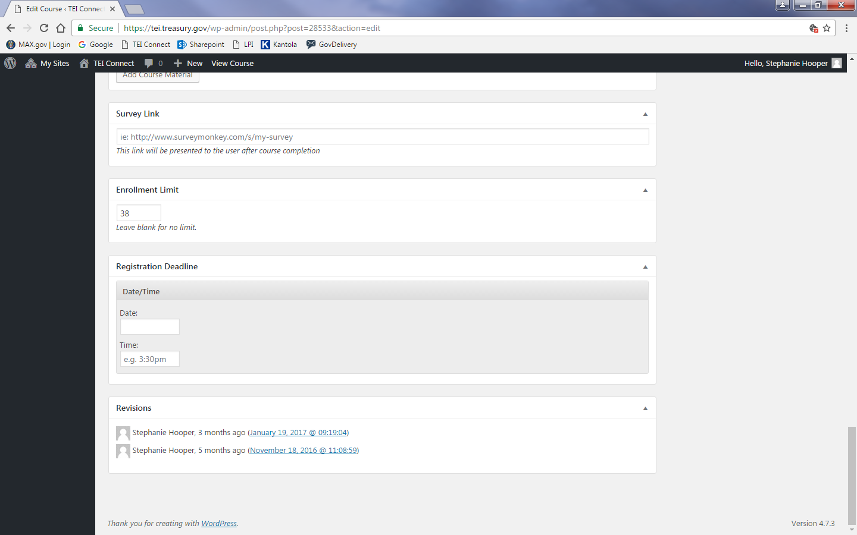

# Control Panel:

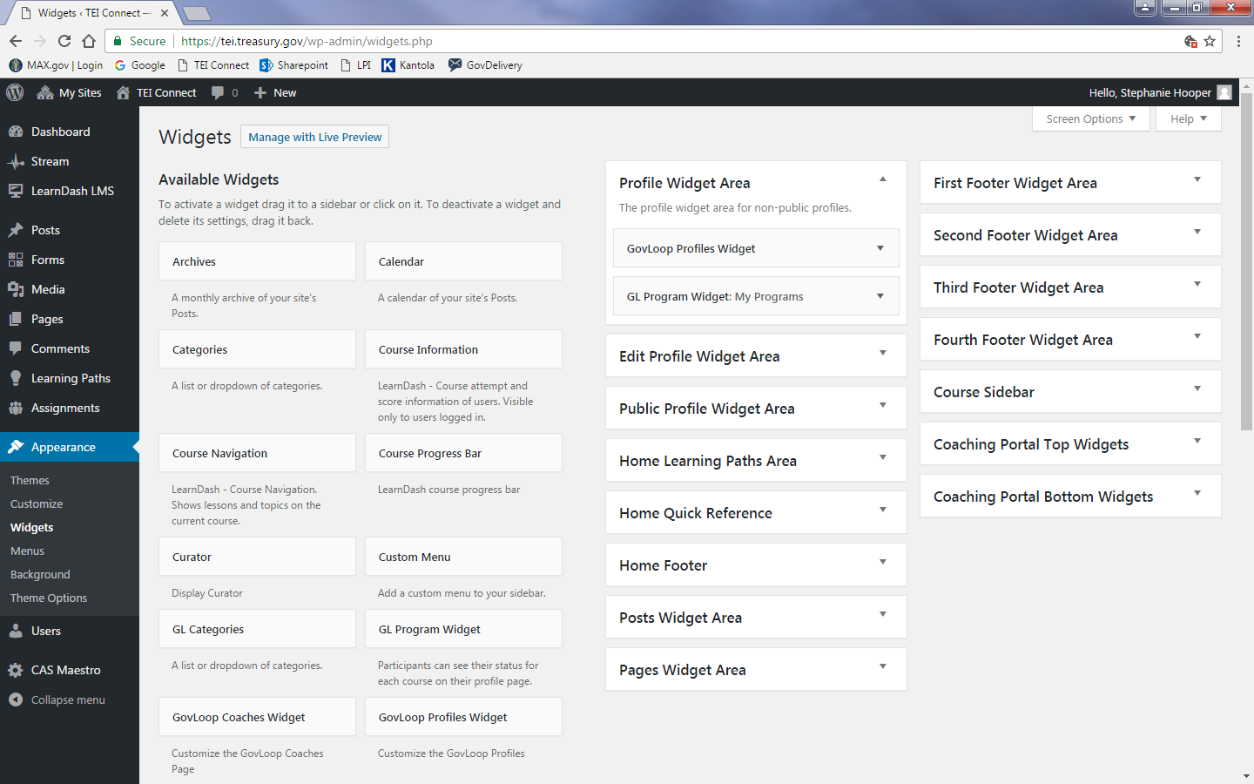

# Coaching Portal:



